Creating New Workflows + Creating & Using Template Workflows

[Echoes - Land Management](https://echoes-platform.eu/app/main/map-view)

21 Steps

Go to <https://echoes-platform.eu/app/main/sites/my-sites> then choose your site you want to create a workflow in.

1 - Creating a Workflow

To start a new workflow;

* Click on the Actions button
* Then click on the 'Create New Workflow' option

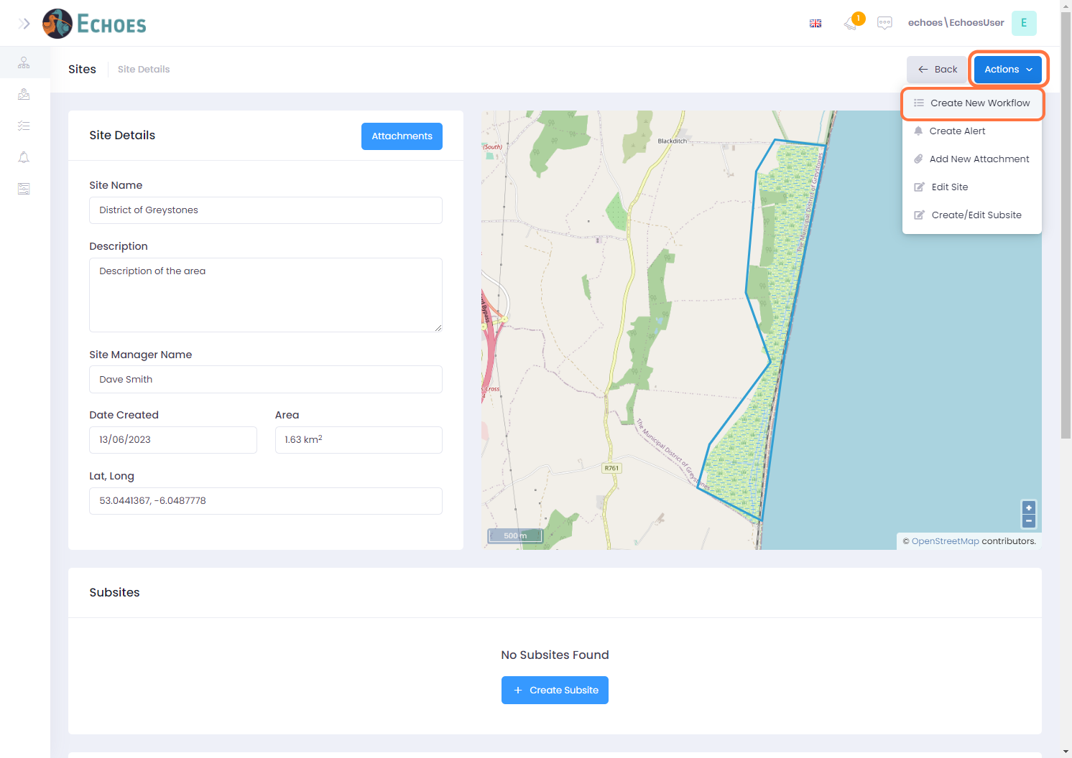

2 - Creating a Workflow from scratch

Here we will click on the 'Create New' option to create a brand-new workflow from scratch.

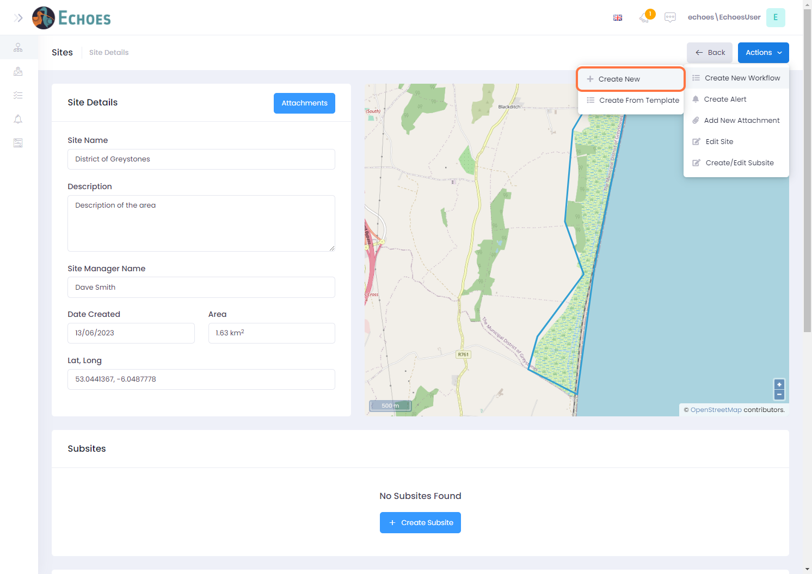

3 - Create Request form

A Create Request form will now open. A **request** is another term for an action you want to take andis the 1st part of the overall workflow. Each request can hold steps within them that need doing to complete a request. Fill out this from by first giving the request a Title.

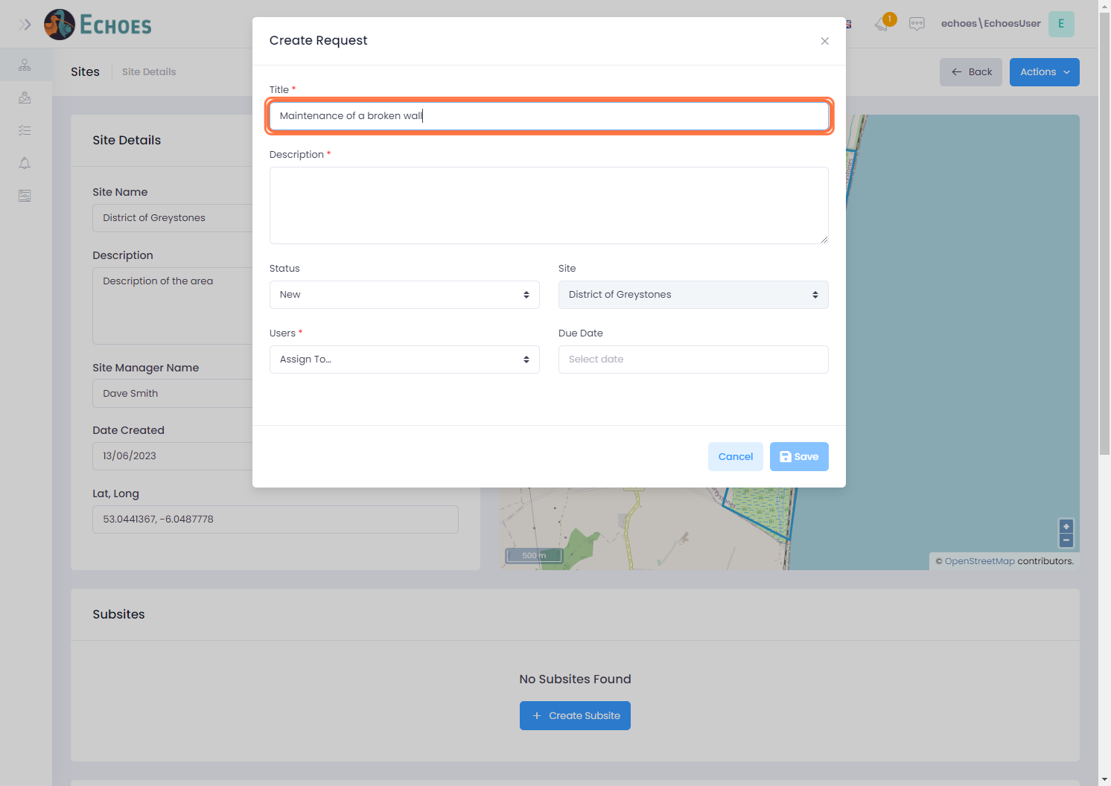

4 - Giving the Request a Description

You will then give a little information around what the request is trying to achieve by giving the request a description.

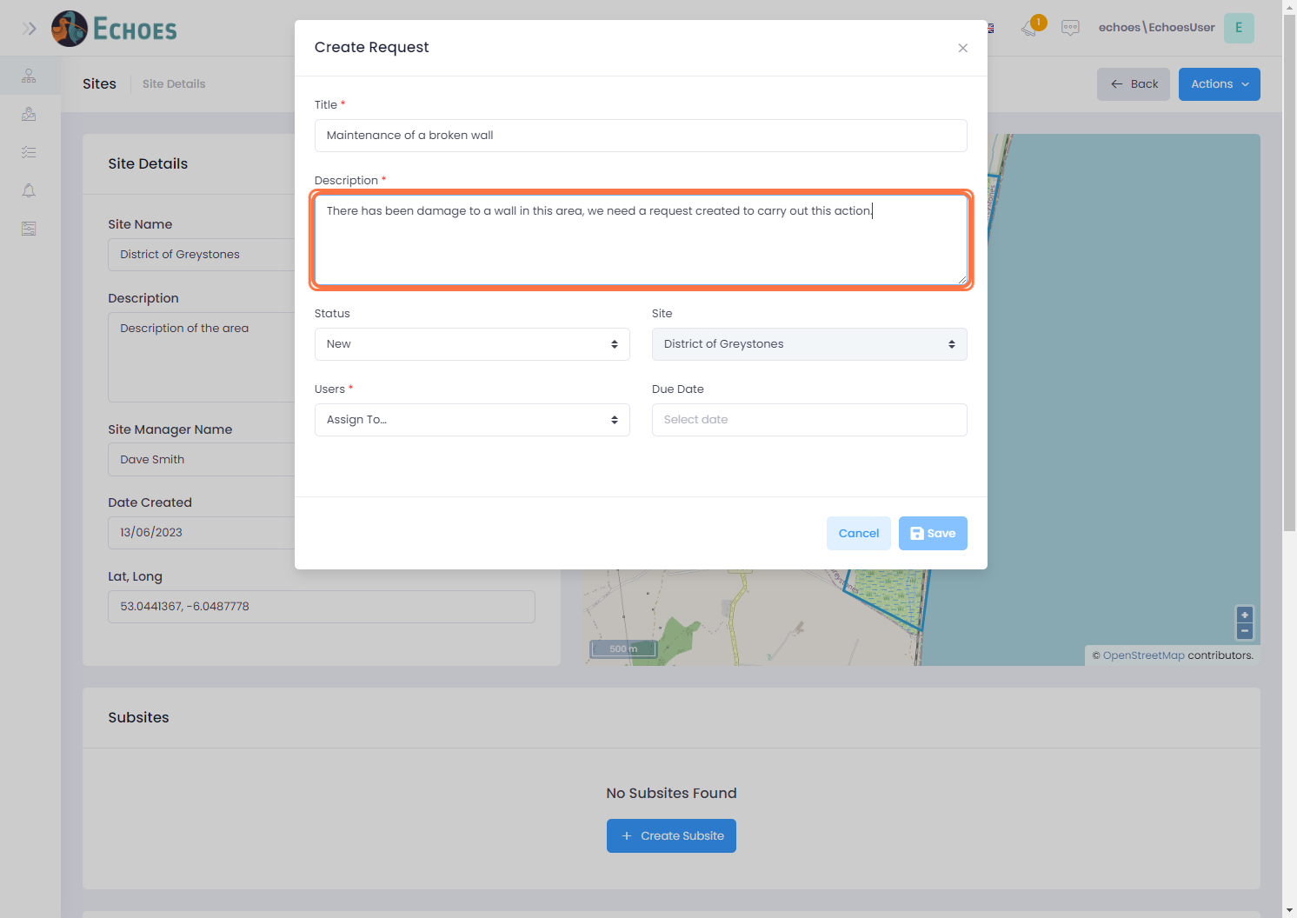

5 - Choosing a Status for the Request

You can give your request a status based by choosing from the Status drop down list.

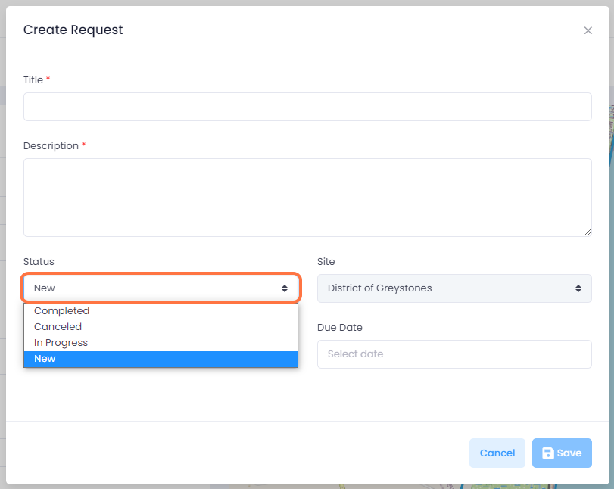

6 - Assigning users to the Request

Choose the users you want to be included in the request or its child steps from the Users drop down list. These can be added to later by editing the request and adding or removing users if needed.

**Note**: If a user is NOT added in here, they cannot be assigned to any steps within the request.

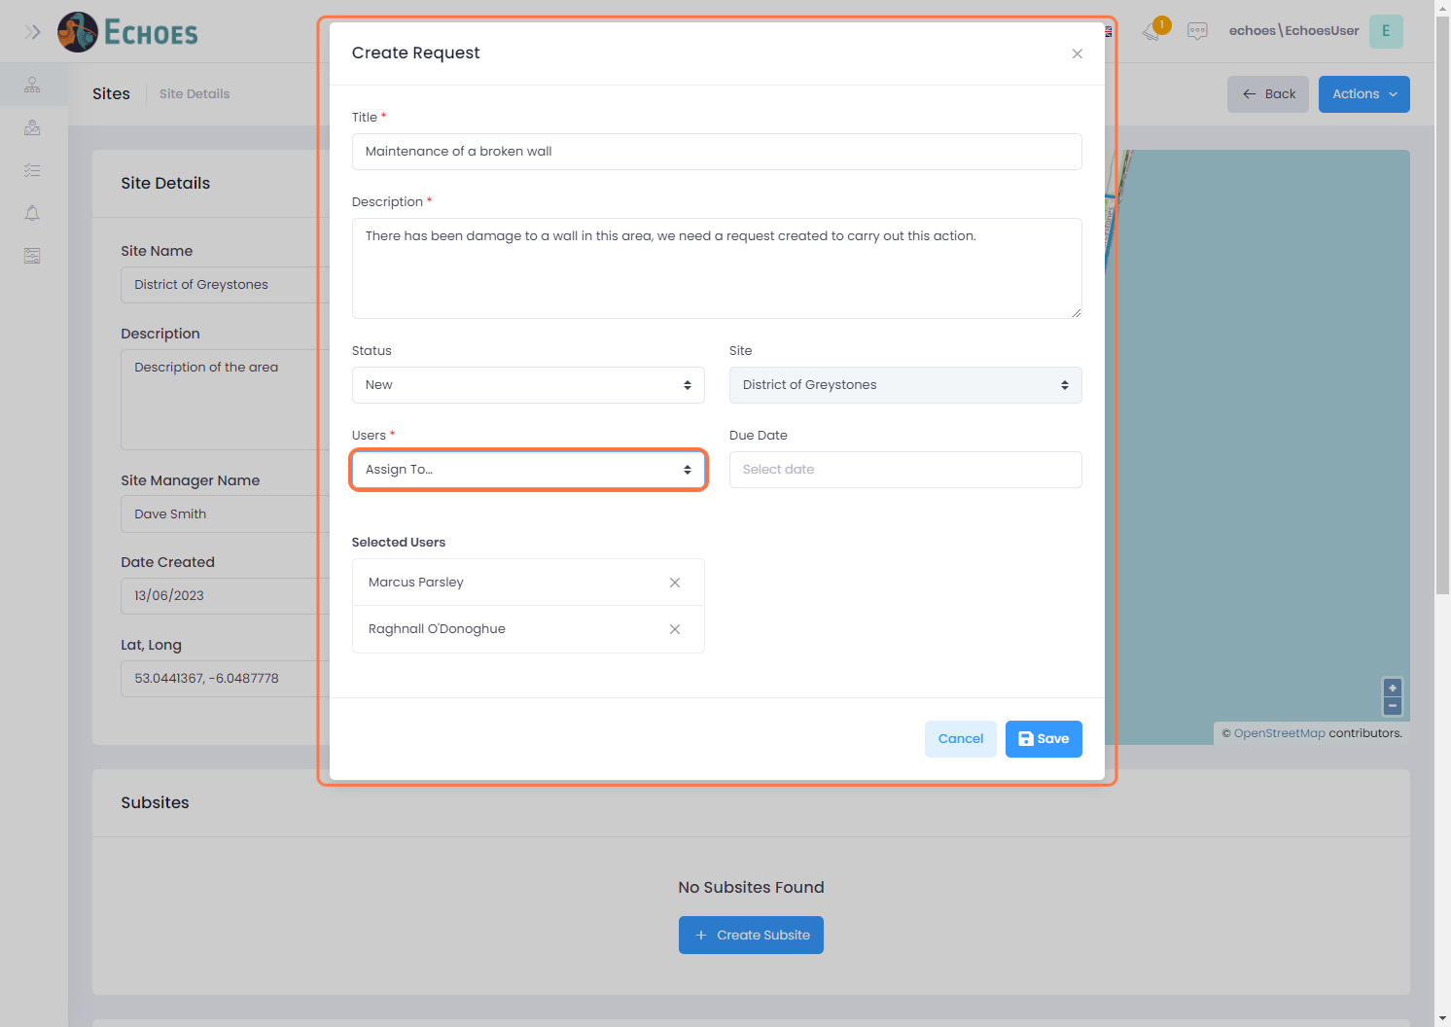

7 - Setting a Due Date for a request

If you know your request needs to be completed by a certain data, you can set a due date for the request. You can do this by selecting one from the Due Date calendar picker.

**Note:** This is not mandatory and can be edited later.

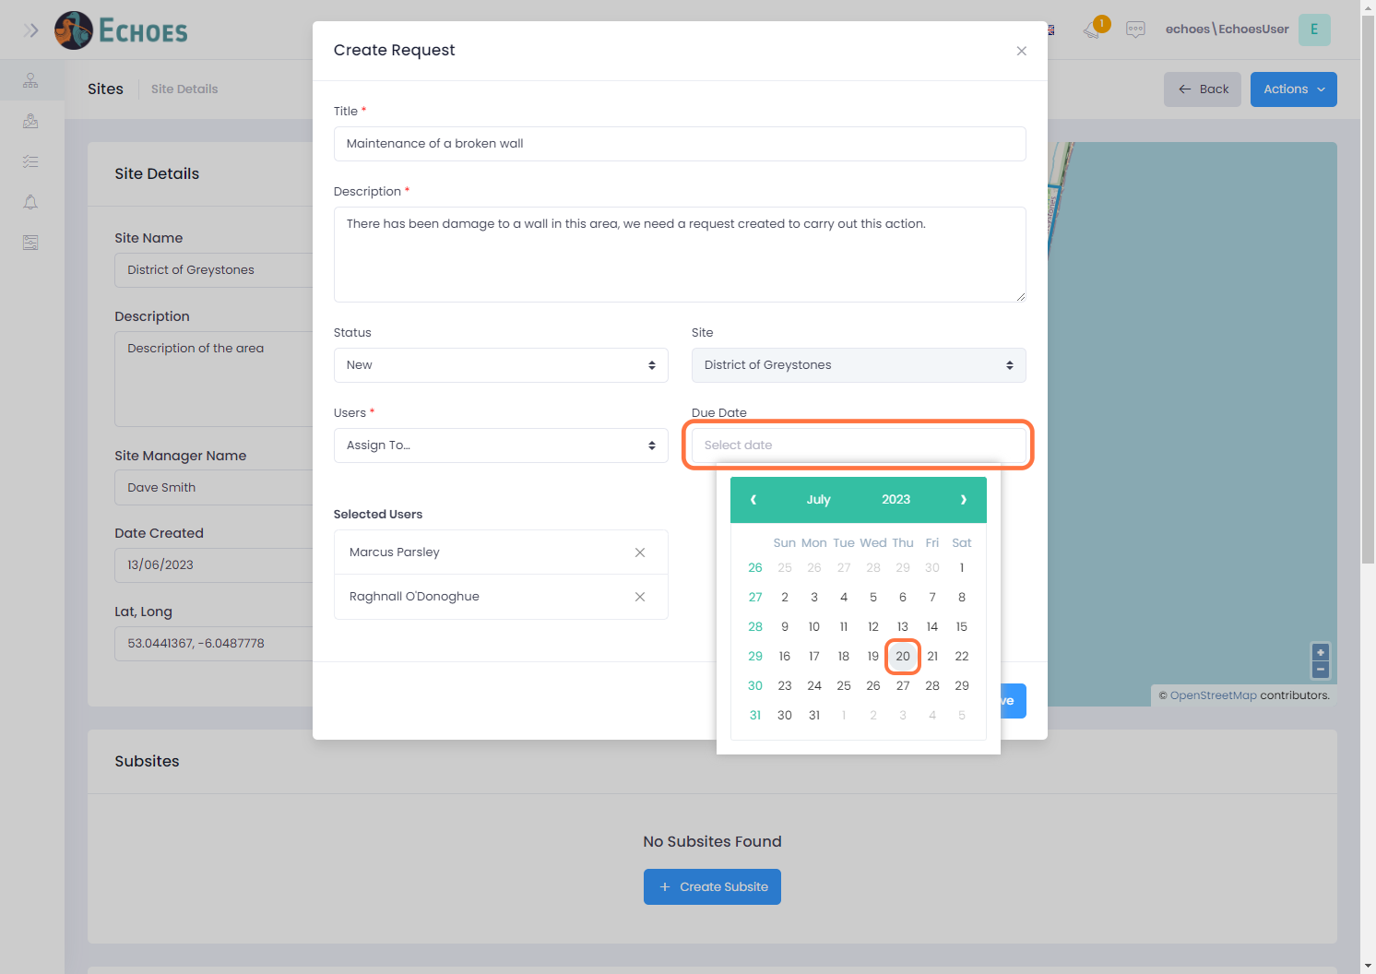

8 - Saving the new Request

Once you are happy with your request, click the 'Save' button.

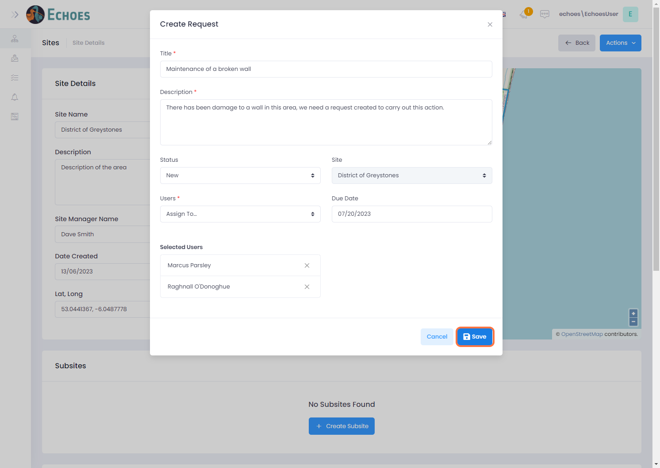

9 - New Request in the Data Grid

You will now see that the request you just created is visible in the Workflows data grid for your site.

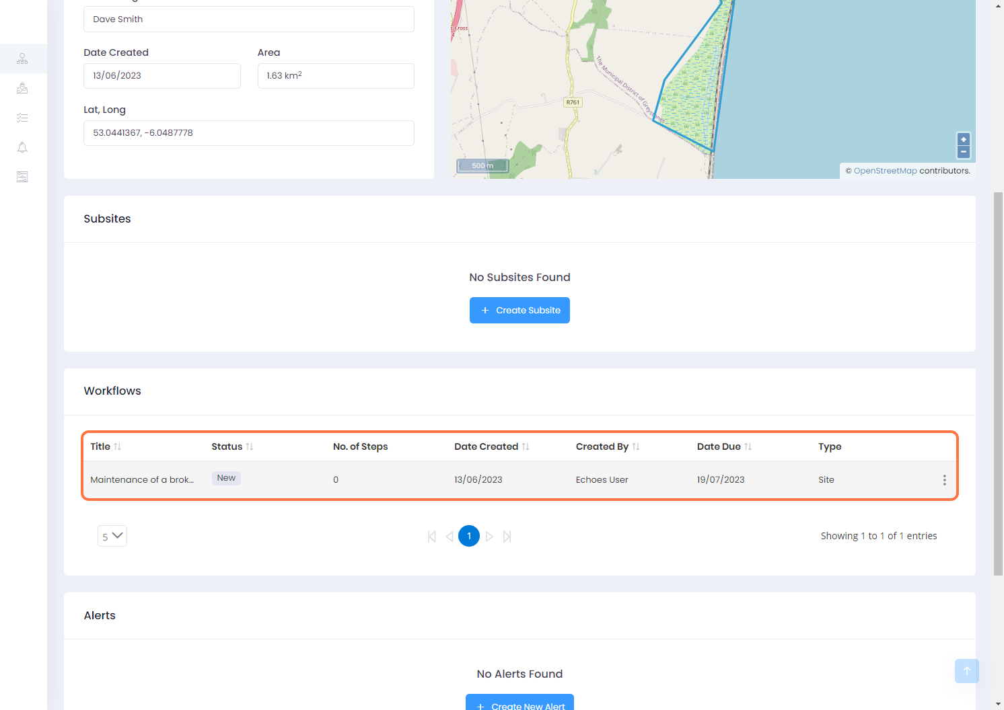

10 - Creating a Template & Editing a Request

These 2 actions are both done in the Edit section of the request. To find this you can click on the ellipses icon of the request you want to use as a template or edit, then choose the 'Edit' option.

**Note:** For demonstration purposes I have added 2 steps within this request to fully show how a template can be used.

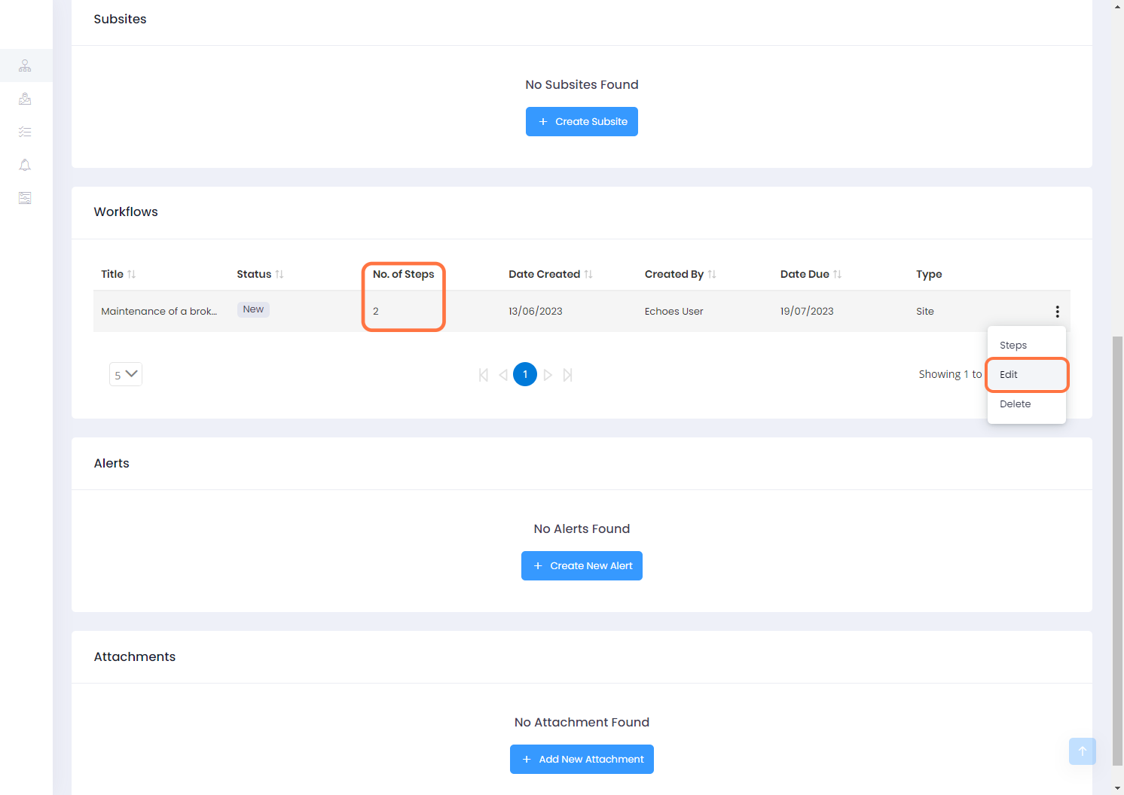

11 - Edit Request Form

* **Edit Request:** Here you can make edits to your request and add attachments using the 'Attachments' button in the top right-hand corner.
* **Use as Template:** You can use this request as a template for future workflows by clicking on the 'Use as Template' button in the bottom left corner of the form.

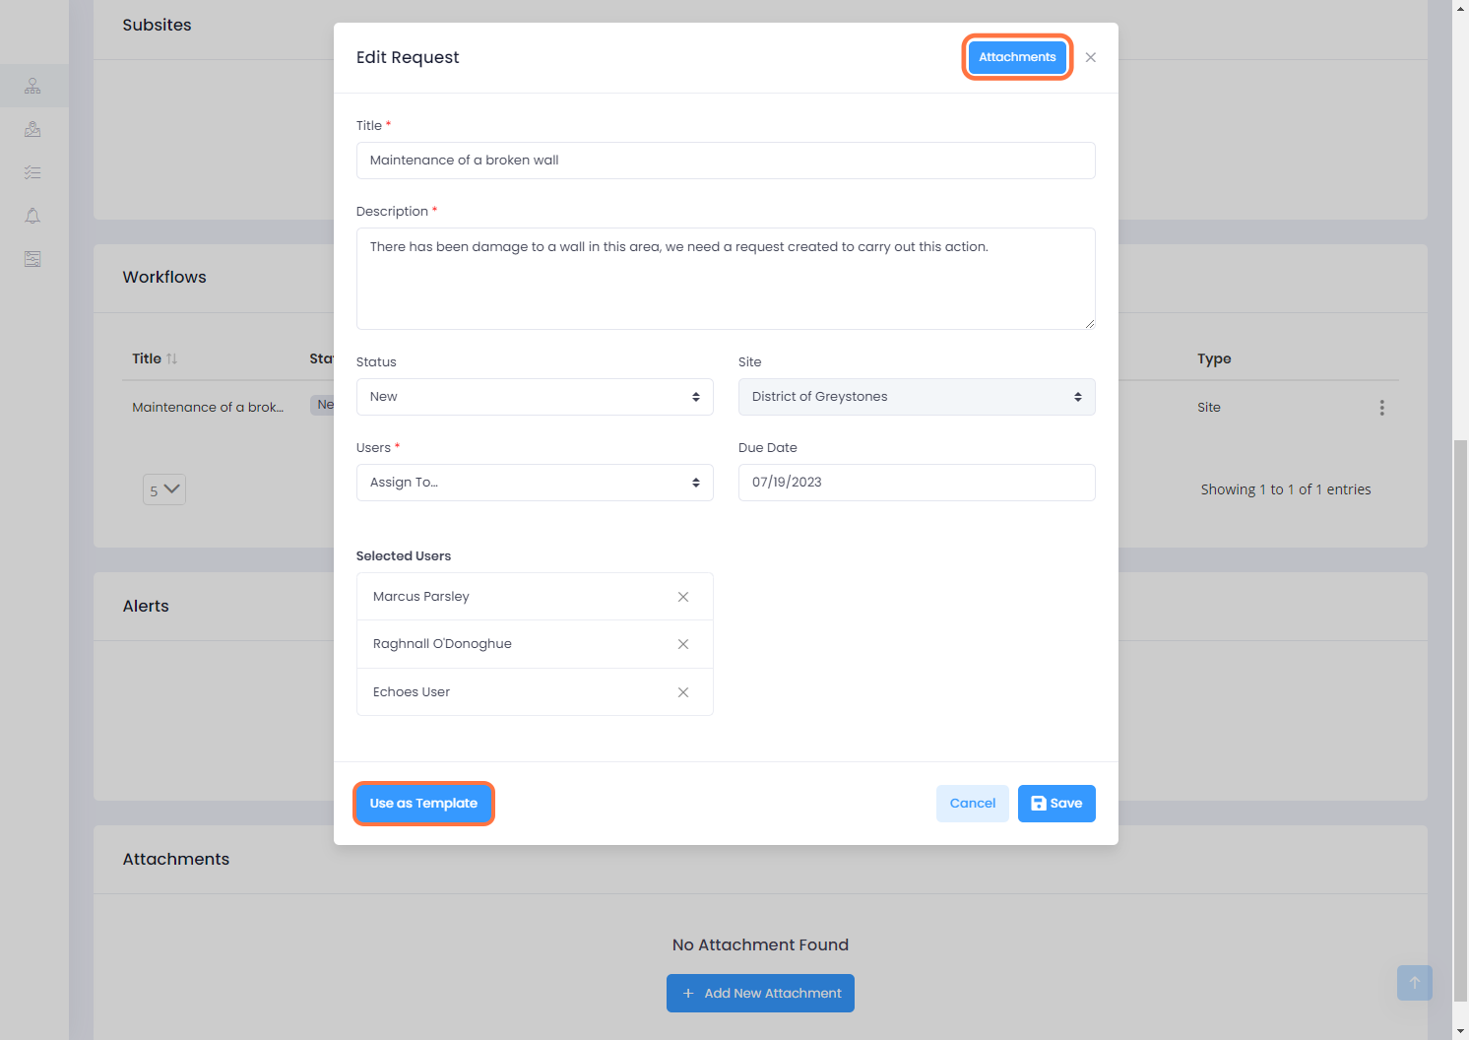

12 - Creating a Workflow Template

A 'Create Workflow Template' form will appear. You can make any edits in here if you wish before saving as a template

**Note:** Once a Template has been made, the template itself cannot be edited, only the information when creating from the template can be changed.

The 'Include Steps' option can be checked if you wish to use the steps within the request you have selected, toggling this off will exclude all steps within this request, alternatively you can deselect individual steps is you wish by clicking the checked box in the 'Include' column.

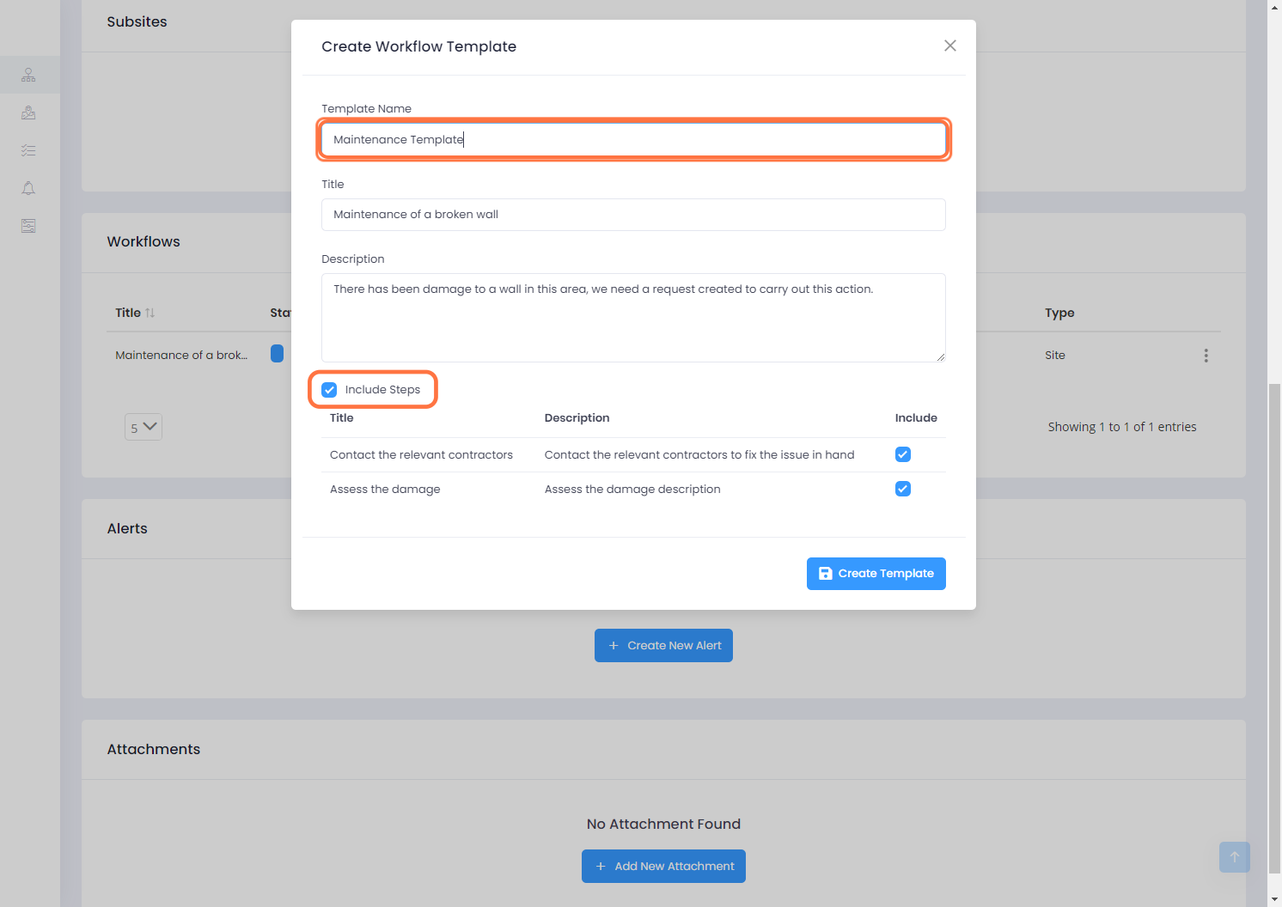

13 - Saving a New Template

Once you are happy with the template you have create you can Click on the 'Create Template' button to save it.

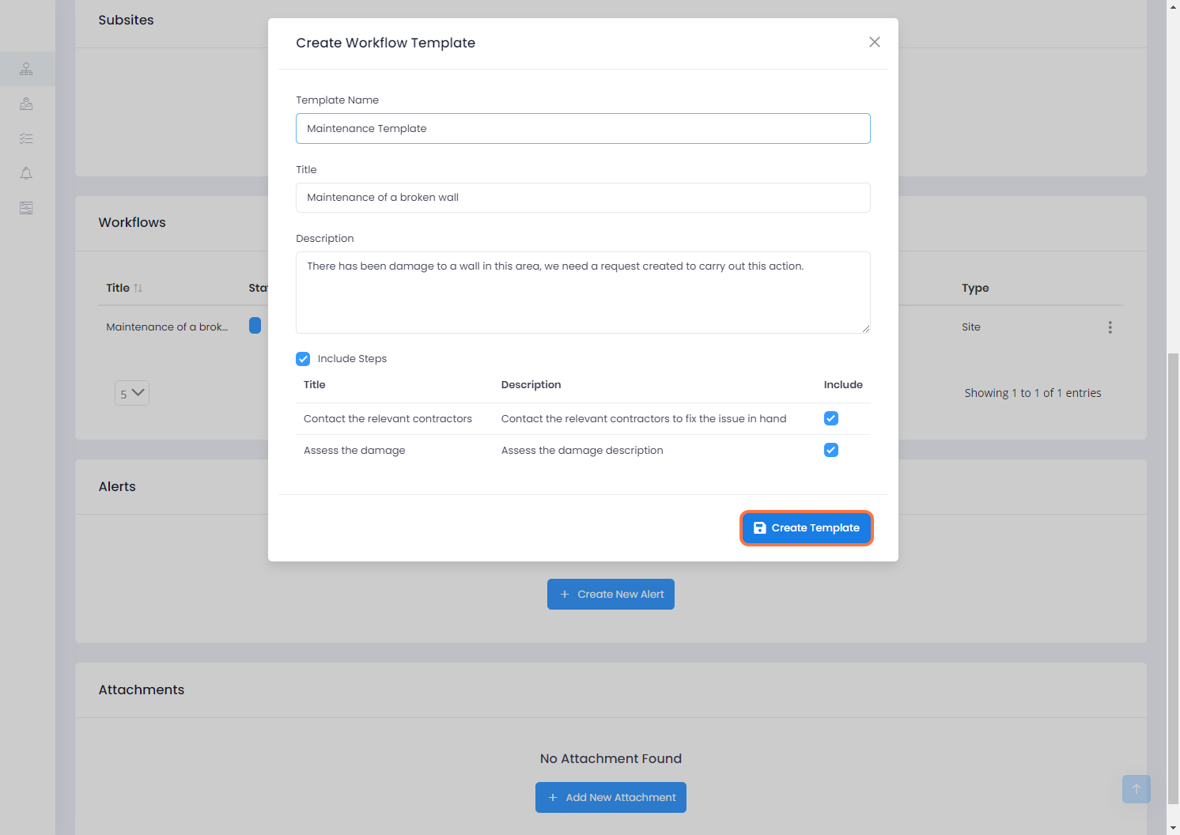

14 - Create a Workflow from a Template

To create a workflow from a Template;

* Click on the Actions button
* Then click on the 'Create New Workflow' option

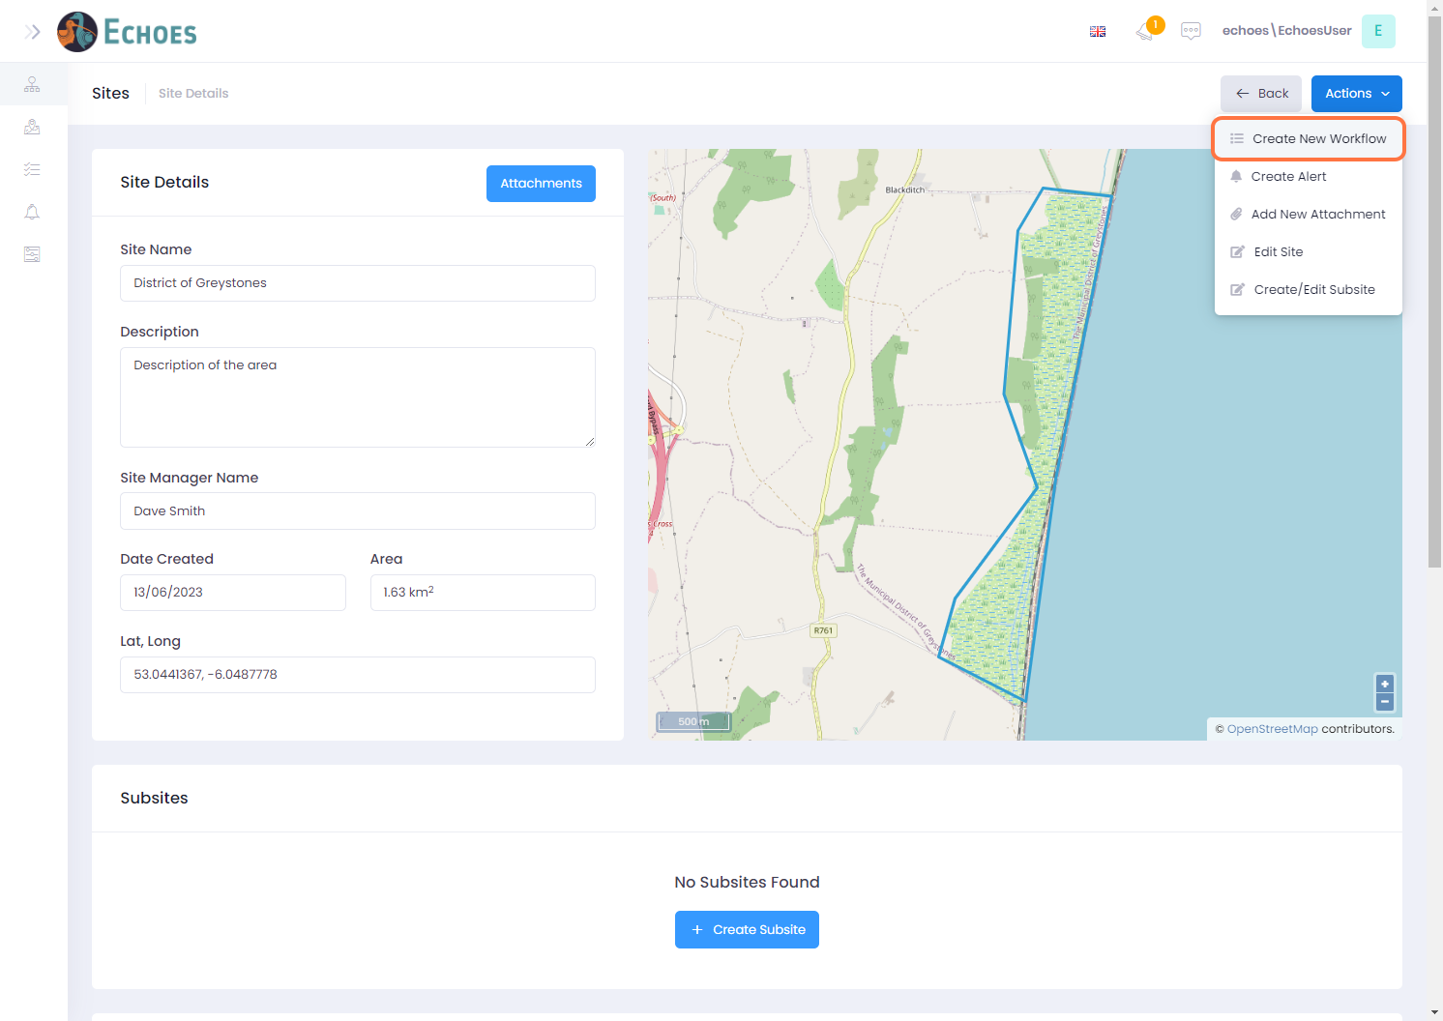

15 - Using a Template

Here we will click on the 'Create from Template' option to choose from your templates.

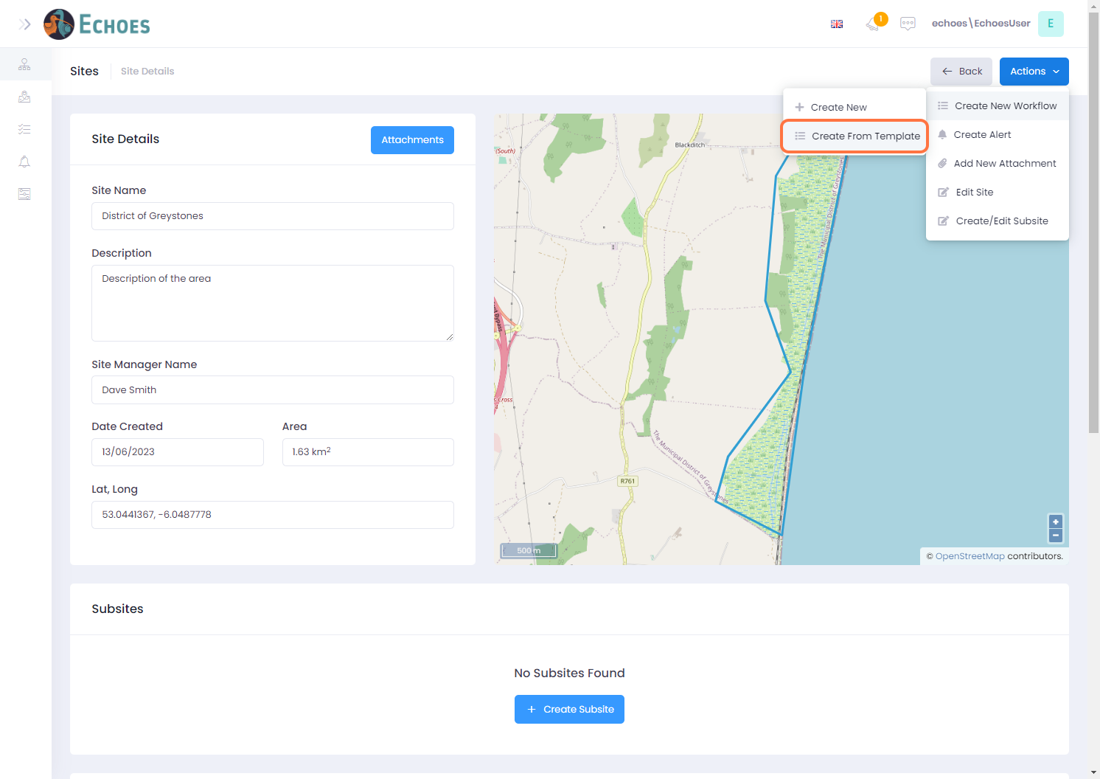

16 - Choose a Template

Your available templates will now show, for this example i will click on the template we just created called 'Maintenance Template'

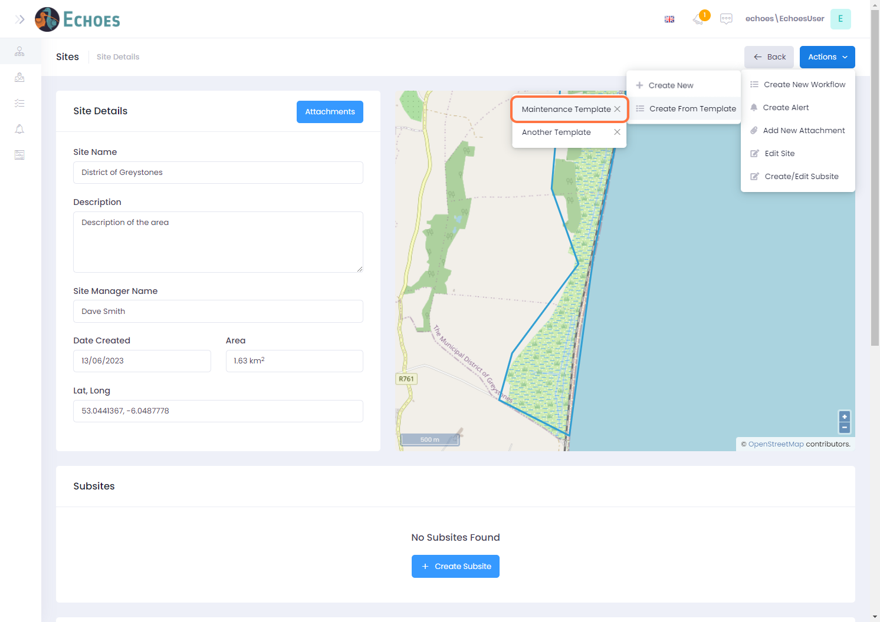

17 - Edit the Templates Title

A form will now open with the same information that was saved when the template was created. You will want to edit this by 1st changing the Title name.

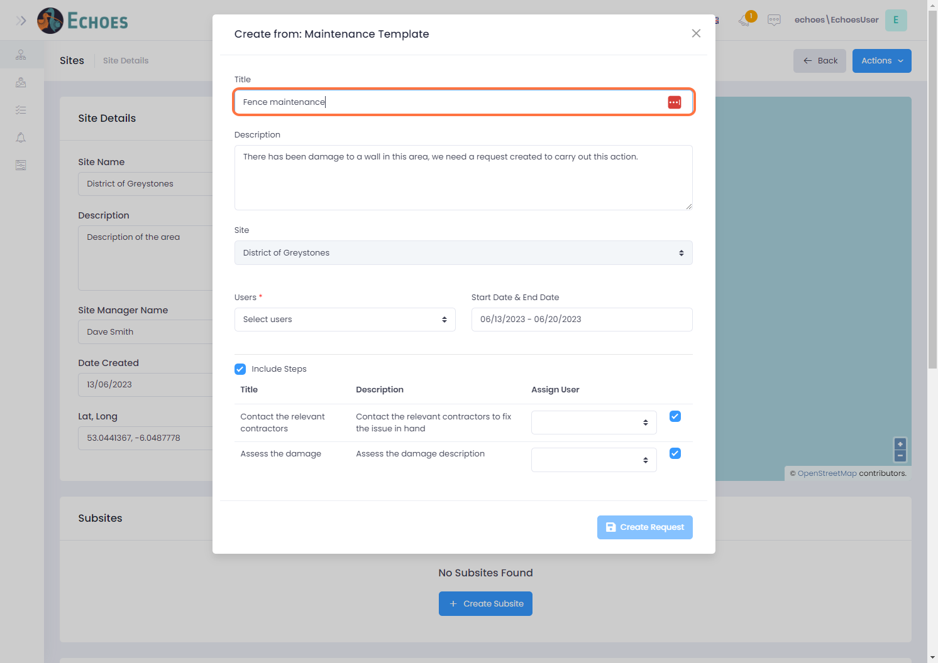

18 - Editing the Templates Description

You may then want to change the templates description.

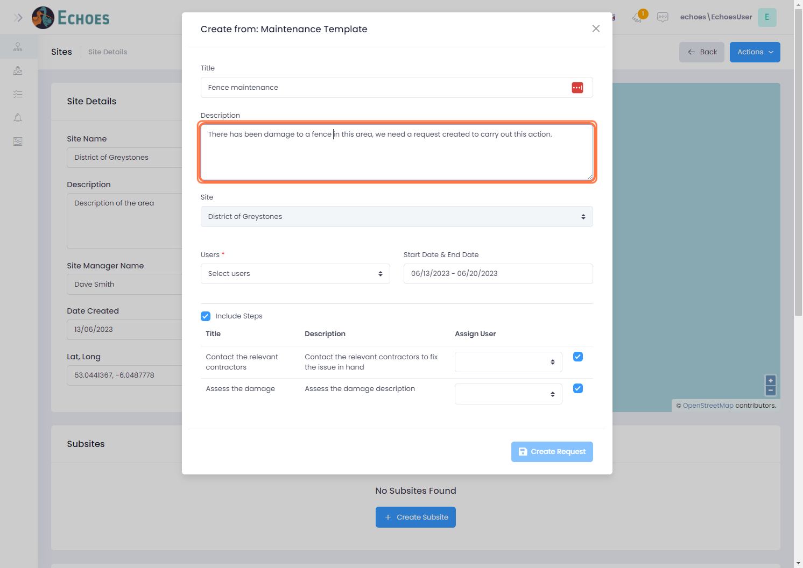

19 - Select uses for the Request

Choose the users you want to be included in the request or its child steps from the Users drop down list. These can be added to later by editing the request and adding or removing users if needed.

**Note**: If a user is NOT added in here, they cannot be assigned to any steps within the request.

Choose from the users in the drop-down list to add to this workflow, these can be changed later. Also choose if you want to include the steps or not.

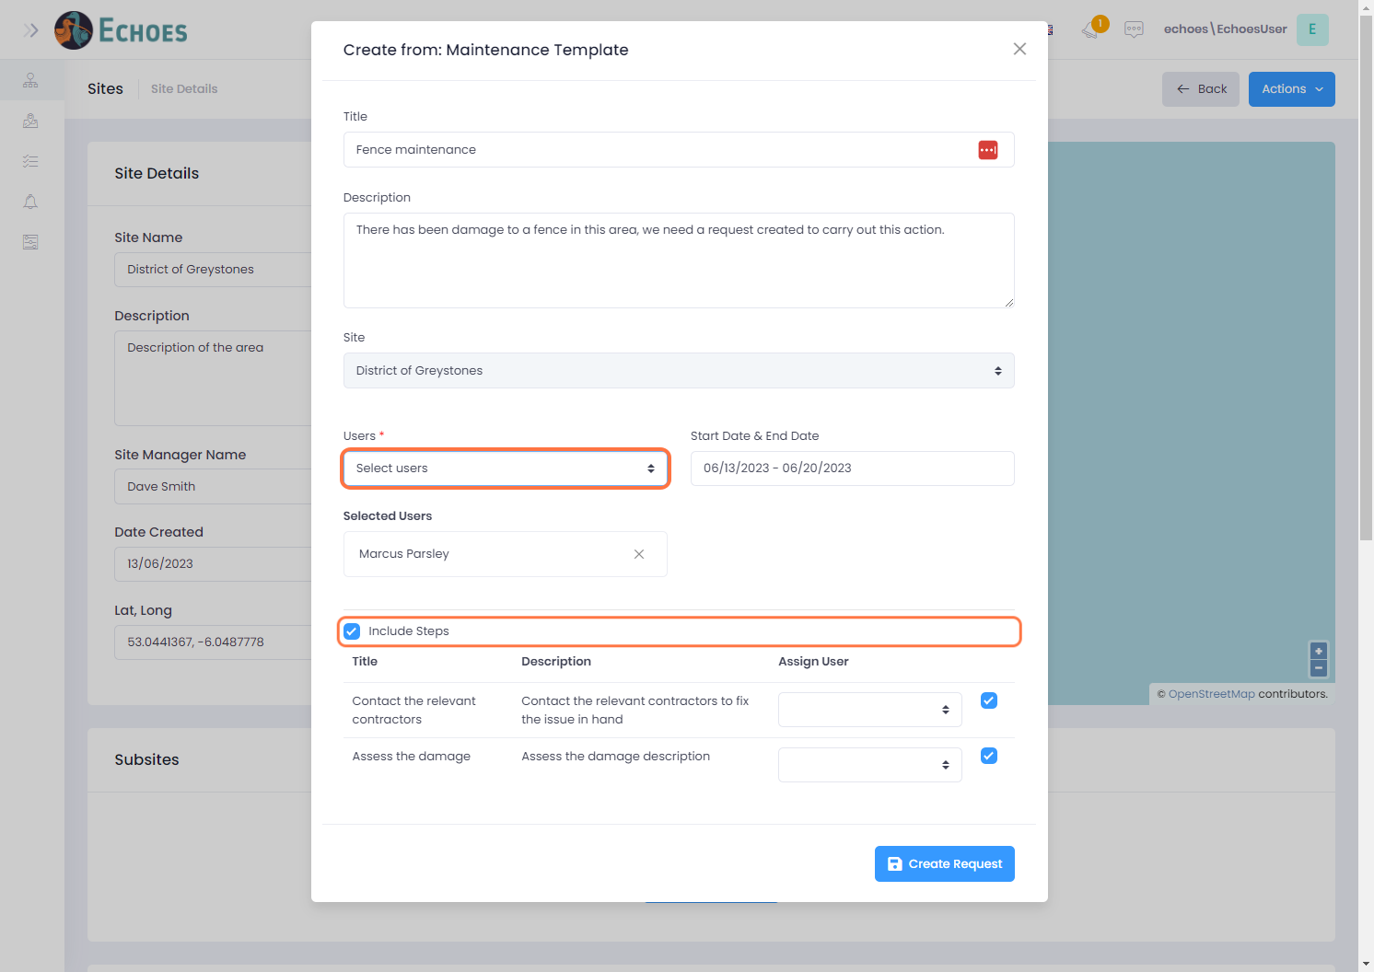

20 - Saving the new request created from a Template

Click on the 'Create Request' button to save the new request

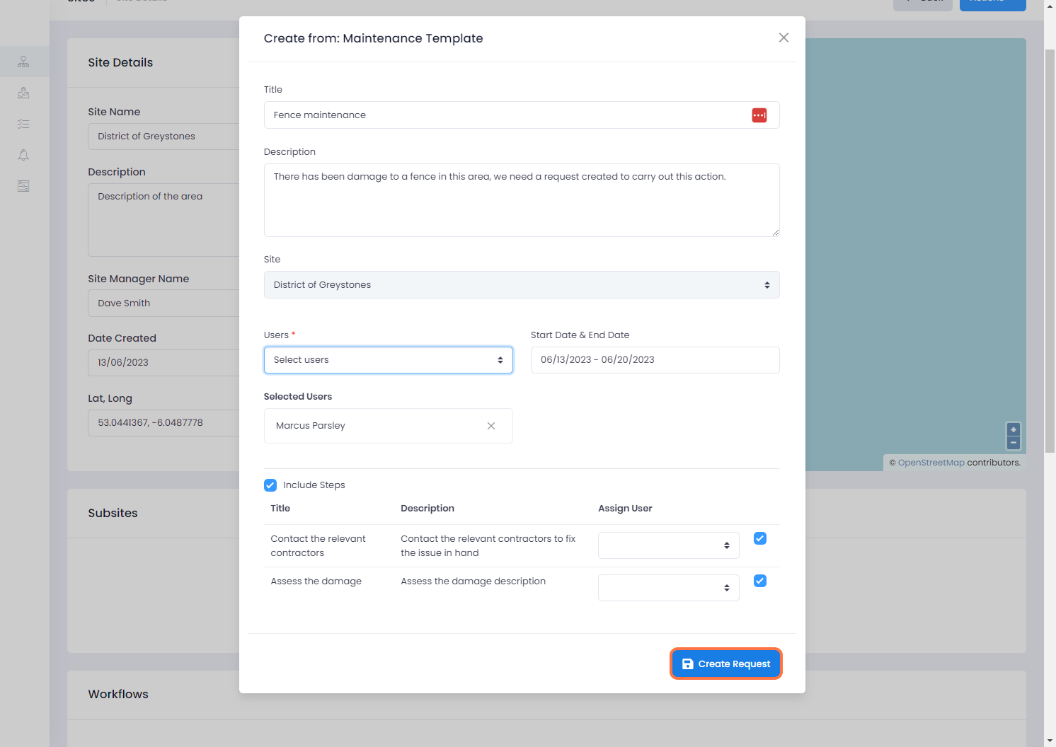

21 - Newly created request now visible in data grid

You can see that the newly created workflow is now in the data grid, with the same number of steps which was given in the template.

